**BPL 2018-19**

[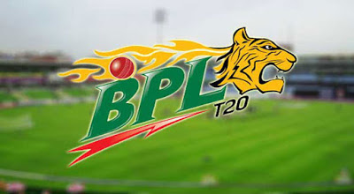](https://3.bp.blogspot.com/-lyHeNrh_yzE/W9WP8DJKXqI/AAAAAAAAAcU/FH0lqNAZXHY8oiuoXRpUE0ySFKqmjibcgCLcBGAs/s1600/Final%2BPlayer%2BList%2Bof%2BBPL.jpg)

**Rangpur Riders**

[](https://2.bp.blogspot.com/-ctUKn7Be5kA/W9WQJJtc8bI/AAAAAAAAAcY/GTLkVkORRi8MVfujHddLLW9ki80Bdp66QCLcBGAs/s1600/Rangpur%2BRiders.jpg)

**Local:**

* Sohag Gazi
* Farhad Reza
* Mehdi Maruf
* Nahidul Islam
* Nadif Chowdhury
* Abul Hossain Raju
* Faraden Hossain Ani
* Mashrafe Bin Mortaza
* Nazmul Islam Apu
* Mohammed Mithun
* Shafiul Islam

**Foreign:**

* Ravi Bopara
* Riley Rousseau
* Beni Howell
* Ocean Thomson
* Chris Gayle
* AB de Villiers
* Alex Heylls

**Dhaka Dynamites**

[](https://1.bp.blogspot.com/-ilUaZUnPznE/W9WQVkTq39I/AAAAAAAAAcg/cBbtKtmZj_cOQAvV2TCGq30SCW_BPWe3gCLcBGAs/s1600/Dhaka%2BDynamites.jpg)

**Local:**

* Shakib Al Hasan
* Shuvagat Hom
* Rony Talukder
* Nurul Hasan Sohan
* Rubel Hossain
* Kazi Anik
* Mizanur Rahman
* Asif Hasan
* Shahadat Hossain Rajib
* Nayeem Sheikh

**Foreign:**

* Sunil Narine
* Ravann Powell
* Kieron Pollard
* Andre Russell
* Hazratullah Zazai
* Andrew Barge
* Ian Bell

**Rajshahi Kings**

[](https://2.bp.blogspot.com/-1B7yMoUIlBo/W9WQheqS2aI/AAAAAAAAAco/Tsqj5ItK0K8GSnba21HyslCSyYvkyw2EwCLcBGAs/s1600/Rajshahi%2BKings.jpg)

**Local:**

* Mominul Haque
* Marshall Ayub
* Kamrul Islam Rabbi
* Mehdi Hassan Miraj
* Mostafizur Rahman
* Zakir Hasan
* Kayes Ahmed
* Alauddin Babu
* Arafat Sunny
* Fazle Rabbi
* Soumya Sarkar

**Foreign:**

* Issuru Udana
* Lori Evans
* Christian Junker
* Ten Doeset Raha
* Sekou Prasad
* Mohammad Sami

**Sylhet Sixers**

[](https://4.bp.blogspot.com/-F5guoHVuyUk/W9WQrnw7q6I/AAAAAAAAAcw/evrlCgf7cqItF_lM_60AnugF050NkO9SwCLcBGAs/s1600/Sylhet%2BSixers.jpg)

**Local:**

* Nasir Hossain
* Sabbir Rahman
* Liton Das
* Afif Hossain Dhruv
* Taskin Ahmed
* Mohammed Al Amin Hossain
* Touhid Hridoy
* Nabil Samad
* Ebadat Hossain
* Alok Kapali
* Zakir Ali
* Gulbadin Nayeem
* Mehdi Hassan Rana

**Foreign:**

* Sohail Tanvir
* David Warner
* Sandeep Lamichan
* Fabian Allen
* Mohammad Irfan
* Andre Fletcher
* Pat Brown
* Nicholas Puran.

**Khulna Titans**

[](https://2.bp.blogspot.com/-wMMw7mBp2mk/W9WRAsZFkSI/AAAAAAAAAc8/1zUE-XcI0qc7PX8OpPbQWM79HVDXED3igCLcBGAs/s1600/Khulna%2BTitans.jpg)

**Local:**

* Mahmudullah Riyad
* Ariful Haque
* Nazmul Hossain Shant
* Mohammad Al Amin
* Taijul Islam
* Shariful Islam
* Zahurul Islam Omi
* Shuvashis Roy
* Junaid Siddiqui
* Tanvir Islam
* Mahidul Islam

**Foreign:**

* Carlos Brathwaite
* David Malan
* Ali Khan
* Zaheer Khan
* Selfan Radarford
* Lasith Malinga
* Yasir Shah
* Brendan Taylor

**Comilla Victorians**

[](https://3.bp.blogspot.com/-x8LuZfQqklk/W9WRM_7yUbI/AAAAAAAAAdE/9SJkABAteZAJGEpV7p0wwPoPCQOaU7TugCLcBGAs/s1600/Comilla%2BVictorians.png)

**Local:**

* Tamim Iqbal
* Imrul Kayes
* Mohammad Saifuddin
* Abu Haider Rony
* Enamul Haque Bijoy
* Mehdi Hasan
* Zia-ur Rahman
* Mosharraf Hossain Rubel
* Mohammad Shaheed
* Shamsur Rahman Shuvo
* Sanjita Saha

**Foreign:**

* Shoaib Malik
* Asila Gunaratnam
* Liam Dawson
* Shahid Afridi
* Thesara Perera
* Evin Lewis
* Waqar Salma Khai
* Amer Yamin.

**Chittagong Vikings**

[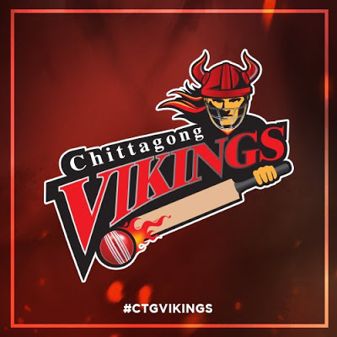](https://1.bp.blogspot.com/-DJr7uquv0OM/W9WRYCuvUeI/AAAAAAAAAdI/zlJnY8DvrTENKS7iKKOppM2cE7m8drvWQCLcBGAs/s1600/Chittagong%2BVikings.jpg)

**Local:**

* Mushfiqur Rahim
* Sanjamul Islam
* Nayeem Hasan
* Syed Khaled
* Ahmed Abu Zaid Rahi
* Mosadde Hossain Saikat
* Mohammad Ashraful
* Rabiul Haque
* Yasir Ali Chowdhury Rabbi
* Nihaduzzaman
* Sadman Islam.

**Foreign:**

* Sikandar Raja
* Luke Ronchi
* Najibullah Zadran
* Ravi Freelink
* Cameron Delport
* Dasun Sanaka
* Nazibullah Zadran

[BPL](https://en.wikipedia.org/wiki/Bangladesh_Premier_League) 2018-19 will start on **January 05**. For more update visit our website.